DIFFERENCE BETWEEN HTTP 1.1 vs HTTP 2

By Subashan Raj T S

# EVOLUTION OF HTTP

Hypertext Transfer Protocol(HTTP) is the existing protocol of the World Wide Web More specifically, HTTP is the method computers and servers use to request and send information. Developed by Tim Berners-Lee and his team between 1989 - 1991. Over the years it went through many changes while shaping its flexibility.

## HTTP/1.1

The first usable version of HTTP was developed in 1997 and it was called HTTP/1.1 .It was in use for almost a decade. When you make a request to a server before sending request and response the client and server establish a communication using Transmission control protocol (TCP) after that you send a request and receive a response , and again you send a request and receive a response the connection will not be lost until all the request is complete. In HTTP/1.1 you can send only one request and receive a response at time. Only after you receive the response for the first request, you can send in the second request. If you didn't receive any response all the other requests will be blocked and the TCP connection is lost. This is the main drawback in HTTP/1.1.

## HTTP 2

HTTP 2 is an upgraded version of HTTP/1.1 which was developed in 2015.It was developed over the SPDY protocol (open networking protocol) which helps us to deliver the web content very fastly and efficiently. This version is a binary framing layer which converts the request into binary code and then sends it to the server, Wherelese HTTP/1.1 is the Text framing layer. It can send multiple requests to a server in parallel in a single TCP connection which allows you to download web content simultaneously. This is the most advanced feature of HTTP 2. This function of HTTP 2 is called Multiplexing.

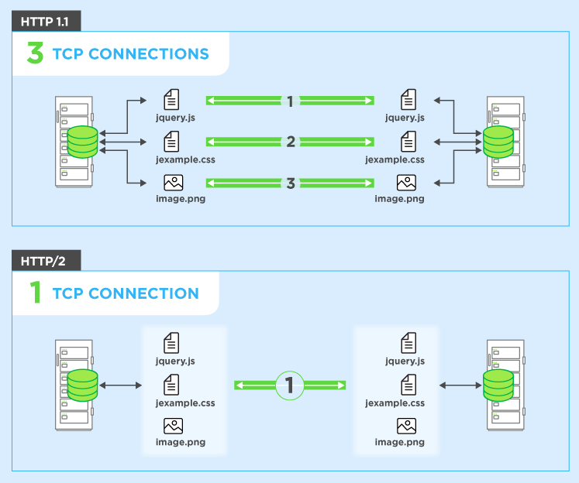

### HTTP 2 SERVER PUSH

This helps the server to send in additional information to the client which is not requested by him, but anticipated in future requests. The client saves the pushed resource in cache and can reuse it across different pages.

